
BAHRIA UNIVERSITY (KARACHI CAMPUS)

OPEN ENDED LAB - I

Computing Fundamentals Lab – CSC 101

Class: BSE 1B (Morning)
Lab Instructor:Engr. Saniya Sarim Time Allowed: 3 hrs.
Date: 05/11/2020 Session: Fall 2020 Max Marks: 3
Student’s Name: M MUAZ SHAHZAD Reg. No: 02-131202-081

Note: (Attempt all questions.)

Q1: Create Data flow diagram, Activity Diagram, Use Case Diagrams of the Online Book Buying system.
DATA FLOW DIAGRAM:
SOLUTION:
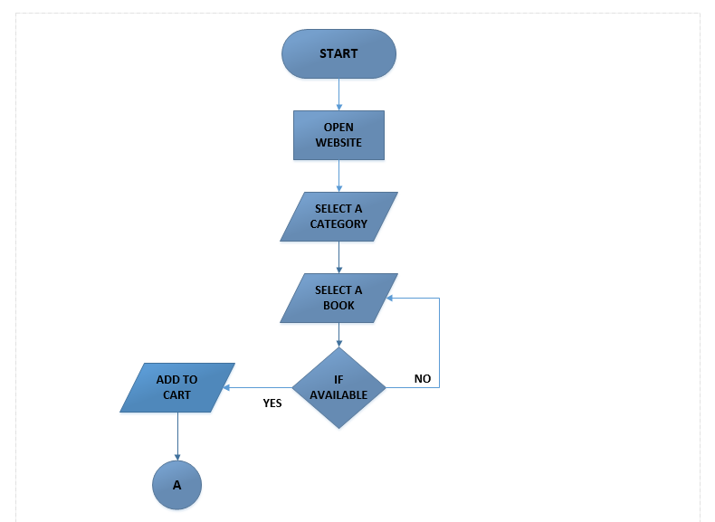

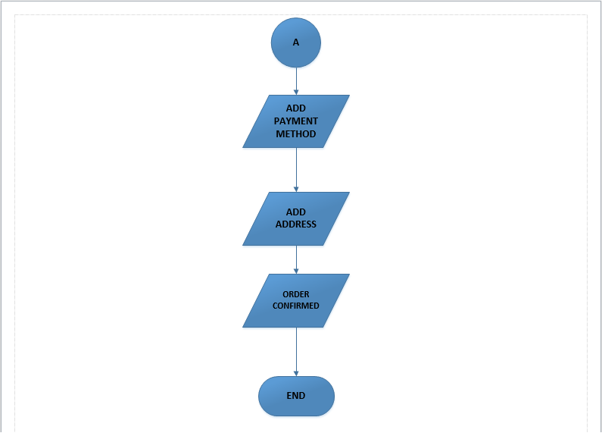

ACTIVITY DIAGRAM:
SOLUTION

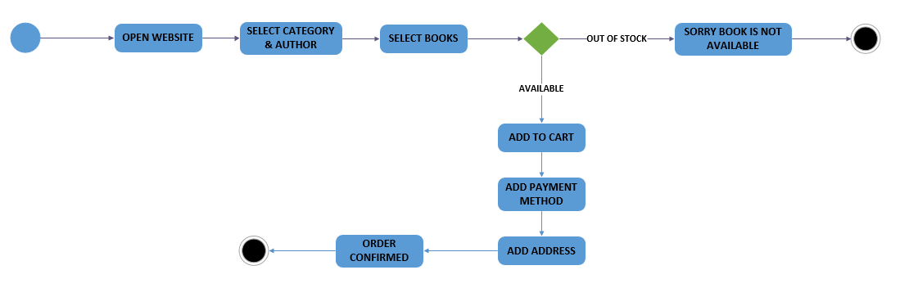

USE CASE DIAGRAM

SOLUTION:
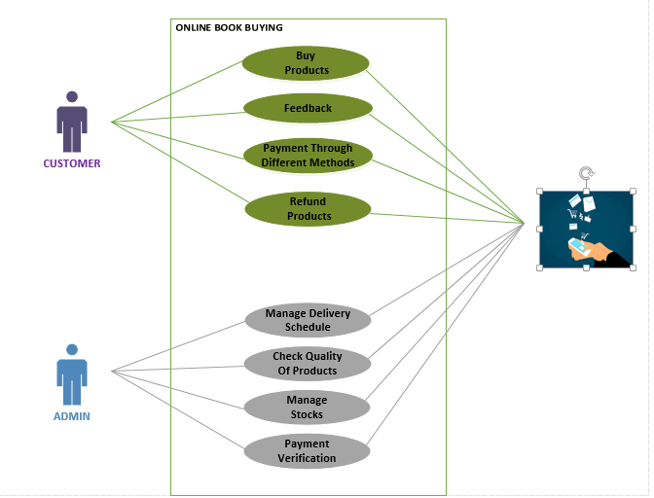

Q2: A well-known Computer Company sales multiple products as show below.
- Laptop (per unit with cost 2100$ and retail price 2400$)
- Usb (per unit with cost 56$ and retail price 60$)
- Hard Disk (per unit with cost 200$ and retail price 220$)
- RAM (per unit with cost 60$ and retail price 67$)
Design sales report showing list of all items, with profit, loss, and tax of 20% GST applies on all items. Mention it on the Sales report.

SOLUTION:
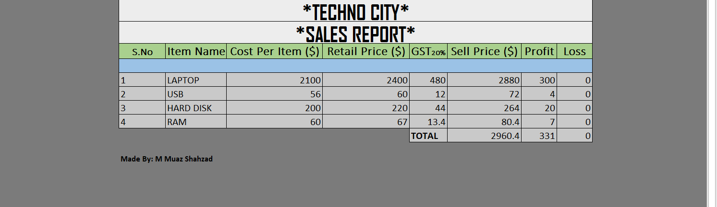

Q3: Create a webpage as shown below with the help of html.

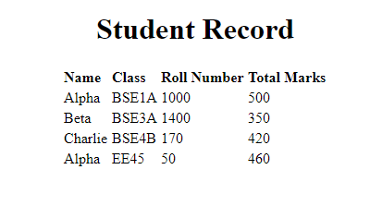

SOLUTION:
<!DOCTYPE html>
<html>
<head>
<title>STUDENT RECORD</title>
</head>
<body style="background:lightyellow;background-size: cover;">
<center><h1 style="font-size: 250%;color: blue">STUDENT RECORD</h1></center><br><br>

<CENTER><table border="1" cellspacing="0"><tr>
<th rowspan="1" style="font-size: 110%;color: black; font-family: arial">NAME</th>
<th rowspan="1" style="font-size: 110%;color: black;font-family: arial" >CLASS</th>
<th rowspan="1" style="font-size: 110%;color: black;font-family: arial">ROLL NUMBER</th>
<th rowspan="1" style="font-size: 110%;color: black;font-family: arial">TOTAL MARKS</th>
<th rowspan="1" style="font-size: 110%;color: black;font-family: arial">MARKS OBTAINED</th>
<th rowspan="1" style="font-size: 110%;color: black;font-family: arial">GRADE</th>
</tr>
<tr>
<td style="font-size: 110%;color: teal;font-family: timesnewroman">M MUAZ</td>
<td style="font-size: 110%;color: teal;font-family: timesnewroman;text-align: center;">BSE-1B</td>
<td style="font-size: 110%;color: teal;font-family: timesnewroman;text-align: center;">043</td>
<td style="font-size: 110%;color: teal;font-family: timesnewroman;text-align: center;">100</td>
<td style="font-size: 110%;color: teal;font-family: timesnewroman;text-align: center;">84</td>
<td style="font-size: 110%;color: teal;font-family: timesnewroman;text-align: center;">A+</td>

</tr>
<tr>
<td style="font-size: 110%;color: teal;font-family: timesnewroman">M HAMZA</td>
<td style="font-size: 110%;color: teal;font-family: timesnewroman;text-align: center;">BSE 1-B</td>
<td style="font-size: 110%;color: teal;font-family: timesnewroman;text-align: center;">044</td>
<td style="font-size: 110%;color: teal;font-family: timesnewroman;text-align: center;">100</td>
<td style="font-size: 110%;color: teal;font-family: timesnewroman;text-align: center;">76</td>
<td style="font-size: 110%;color: teal;font-family: timesnewroman;text-align: center;">A</td>
</tr>
<tr>
<td style="font-size: 110%;color: teal;font-family: timesnewroman">M TALHA</td>
<td style="font-size: 110%;color: teal;font-family: timesnewroman;text-align: center;">BSE 1-B</td>
<td style="font-size: 110%;color: teal;font-family: timesnewroman;text-align: center;">045</td>
<td style="font-size: 110%;color: teal;font-family: timesnewroman;text-align: center;">100</td>
<td style="font-size: 110%;color: teal;font-family: timesnewroman;text-align: center;">74</td>
<td style="font-size: 110%;color: teal;font-family: timesnewroman;text-align: center;">A</td>

</tr>
<tr>
<td style="font-size: 110%;color: teal;font-family: timesnewroman">M ALI</td>
<td style="font-size: 110%;color: teal;font-family: timesnewroman;text-align: center;">BSE 1-B</td>
<td style="font-size: 110%;color: teal;font-family: timesnewroman;text-align: center;">046</td>
<td style="font-size: 110%;color: teal;font-family: timesnewroman;text-align: center;">100</td>
<td style="font-size: 110%;color: teal;font-family: timesnewroman;text-align: center;">70</td>
<td style="font-size: 110%;color: teal;font-family: timesnewroman;text-align: center;">A</td>

</tr>
<tr>
<td style="font-size: 110%;color: teal;font-family: timesnewroman">M USAMA</td>
<td style="font-size: 110%;color: teal;font-family: timesnewroman;text-align: center;">BSE 1-B</td>
<td style="font-size: 110%;color: teal;font-family: timesnewroman;text-align: center;">047</td>
<td style="font-size: 110%;color: teal;font-family: timesnewroman;text-align: center;">100</td>
<td style="font-size: 110%;color: teal;font-family: timesnewroman;text-align: center;">87</td>
<td style="font-size: 110%;color: teal;font-family: timesnewroman;text-align: center;">A+</td>

</tr>
</table></CENTER>

</body>
</html>

OUTPUT:
